“Київський фаховий коледж зв’язку”

Циклова комісія комп’ютерної та програмної інженерії

**ЗВІТ ПО ВИКОНАННЮ**

**ЛАБОРАТОРНОЇ РОБОТИ №3**  
з дисципліни: «Операційні системи»  
Тема: “Команди Linux для управління процесами”

Виконали студенти

групи БІКС-13

Команда JRSY: Андрущик П.С   
Бурбан Д.Ю.  
Перевірив викладач

Сушанова В.С.

Київ 2023

**Preparation Assignment: (виконала студентка Андрущик Поліна)**

1. **\*Read the brief theoretical information for the laboratory work and create a small dictionary of basic English terms related to the purpose of commands and their parameters.**
2. **Based on the material discussed, answer the following questions:**

**2.1. *What commands for monitoring the state of processes do you know? How can you view their possible parameters?**

**2.2. *Can the "ps" command track the state of processes in real-time?**

**2.3. **What parameters can processes be sorted by in the "top" command? How do you switch between them?**

**2.4. **What commands do you know for terminating processes?**

1. **Read the material on working with processes in the terminal:**
   * **Processes in Linux. Process Management**
   * **Find out what processes are running in the background on Linux**
2. **Prepare the initial version of the report in electronic form.**

**Progress: (виконав студент Бурбан Данило)**

1. **Initial work in CLI mode on the Linux operating system:**
   * Installed and launched the terminal.
2. **Answer the following questions:**
   * **How to display the contents of the /proc directory? Where is it located and what is its purpose?**

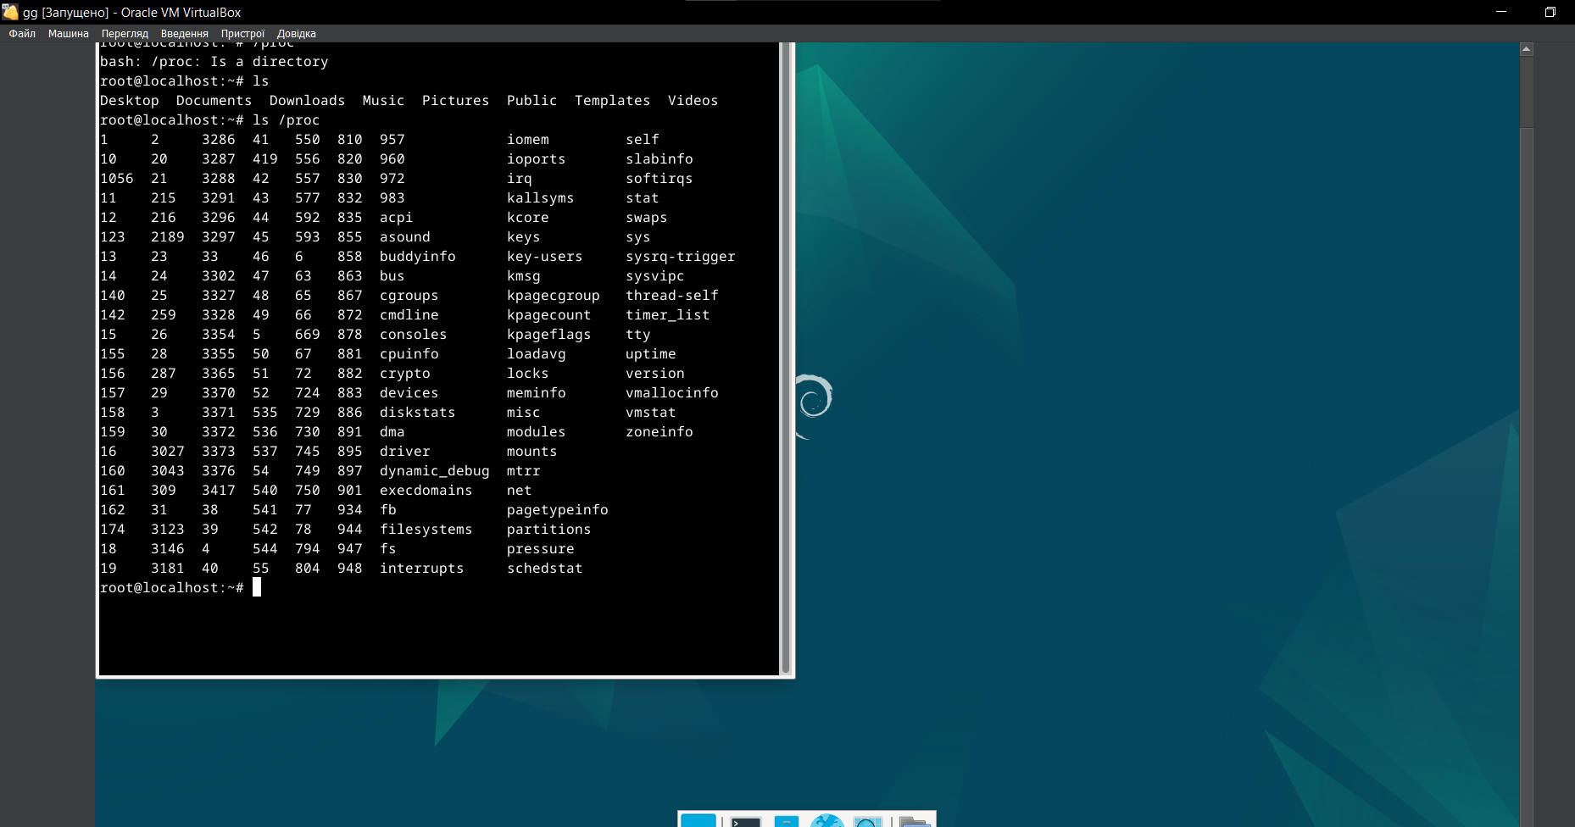

Display using the "ls /proc" command. This directory contains information about system resources, such as processes, memory, and devices. Here are some important files and directories in /proc and their descriptions:

* + Processes:

Each process has its own subdirectory in /proc with a name corresponding to its Process ID (PID). For example, /proc/1234/ contains information about the process with PID 1234.

* + CPU Information (cpuinfo):

/proc/cpuinfo contains information about the processor, such as model, number of cores, cache size, and other characteristics.

* + Memory Information (meminfo):

/proc/meminfo contains information about memory usage, including total, free, and available memory, as well as details about swap space.

**/proc/meminfo** надає інформацію про використання оперативної та віртуальної пам'яті системи, включаючи вільну, використану та буферизовану пам'ять.

* **Kernel Version (version):**

**/proc/version contains information about the Linux kernel version and some changes in the kernel's system file.**

* **Loaded Kernel Modules (modules):**

**/proc/modules lists the loaded kernel modules and their parameters.**

* **Mounted File Systems (mounts):**

**/proc/mounts contains information about all mounted file systems on the system.**

* **System Parameters (sys):**

**/proc/sys/ is the root directory for many system parameters that can be read and modified to control various aspects of the system.**

* **Kernel Command Line Parameters (cmdline):**

**/proc/cmdline contains the kernel command line parameters with which the kernel was launched.**

* **System Uptime (uptime):**

**/proc/uptime provides information about the system's uptime and idle time.**

**How to display information about current user sessions. Which command can be used for this?**

**You can display information about current user sessions using the who command in the terminal.**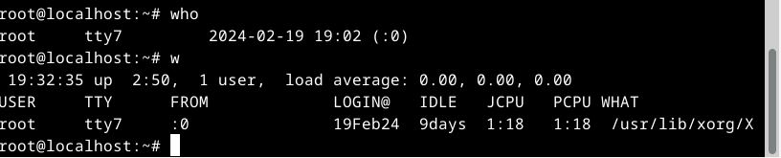

Keyboard shortcuts Ctrl + C, Ctrl + D, and Ctrl + Z in the terminal are used for process management and interacting with commands.

Ctrl + C: This key combination interrupts the execution of the current command or program. It is used to stop the execution of a command or program invoked in the terminal.

Ctrl + D: This key combination serves as an End-of-File signal. It is entered to signify the end of input.

Ctrl + Z: This key combination suspends the execution of the current process and puts it in the background.

What distinguishes a background process from a regular one? Where are they used?

A background process operates in the background, not associated with the terminal, while a regular process is tied to the terminal from which it was launched. Background processes can continue running even if you exit the terminal.

Background processes are commonly used in scenarios where you want a task to run independently of the terminal session. For example, you might start a time-consuming task in the background so that it doesn't tie up your terminal, and you can continue using the terminal for other tasks.

Descriptions of the commands: jobs, bg, fg:

* jobs Command:

The jobs command displays a list of active processes, both those running in the background and those stopped. It provides information about the jobs associated with the current shell session, including their job number, status, and command.

* bg Command:

The bg command is used to resume (move to the background) stopped tasks or jobs. When a process is suspended (usually by Ctrl + Z), it can be resumed in the background using bg. This allows the process to continue running while freeing up the terminal for other tasks.

* fg Command:

The fg command is used to bring a background task to the foreground, making it the active task in the terminal. It is commonly used with the job number (e.g., fg %1), where %1 represents the job number. This is useful when you want to interact with a background task or switch back to a task that was moved to the background.

Which command can be used to view information about running background processes and tasks?

The command "jobs."

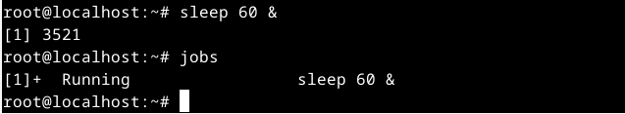

**How to suspend a background process, then resume it, and if necessary, restart it?** "Ctrl + Z" to suspend, then "bg %" to resume.

1. **Launch the terminal and execute the following actions to familiarize yourself with process management:**
   * Run the "top" command, analyze the results obtained with this command, and characterize the most active processes in the system.

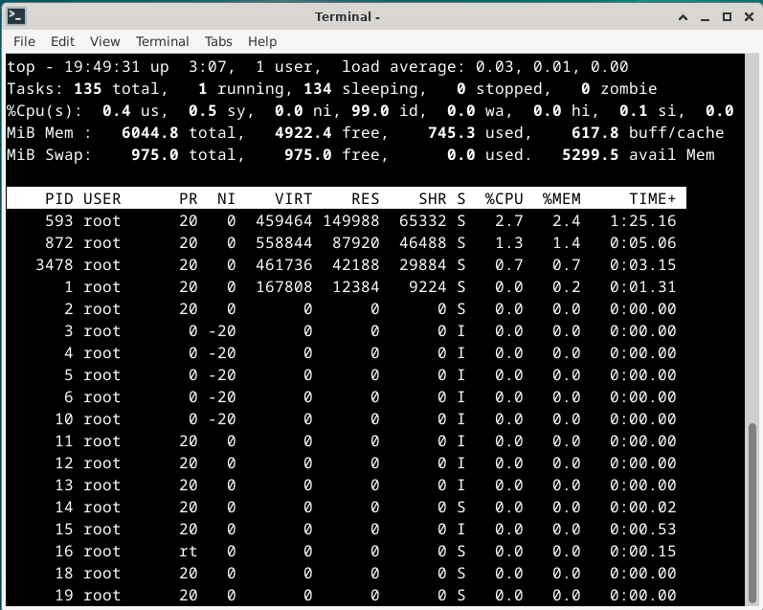

•  **134 tasks, 1 running, 133 in sleep mode.**

• **Memory usage, free, and cache:**

* To obtain detailed information about memory usage, free memory, and cache, you can refer to the output of the "top" command, typically located under the "Mem:" and "Swap:" sections. This provides information about total memory, used memory, free memory, and cache usage.

• **Suspend the execution of the "top" command (use the key combination):**

* Press "Ctrl + Z" to suspend the execution of the "top" command.



Display information about processes using the "ps" command.

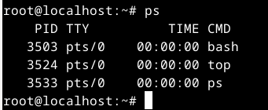

* *Provide 5 examples using different parameters of the "ps" command (e.g., display only system processes, display processes of a specific user, display process tree, etc.):*
* Display all processes of a user:

ps -u username

* Display the process tree for a specific process:

ps -ejH

* Display detailed real-time information about processes:

ps aux

* Display only processes of a specific command:

ps -C process_name

* Display only system processes:

ps -e

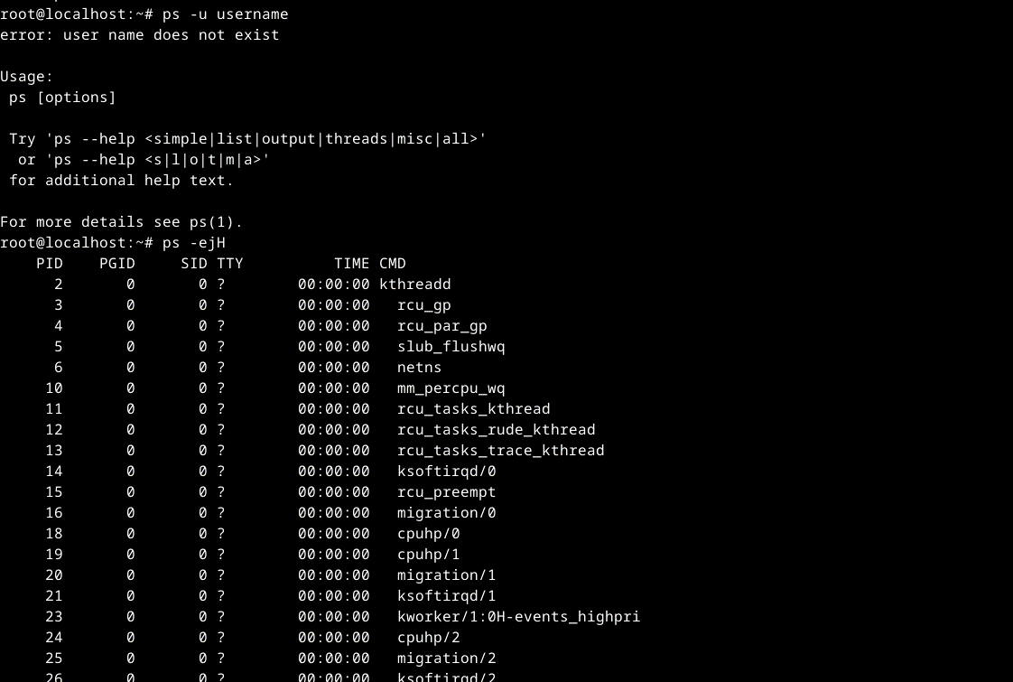

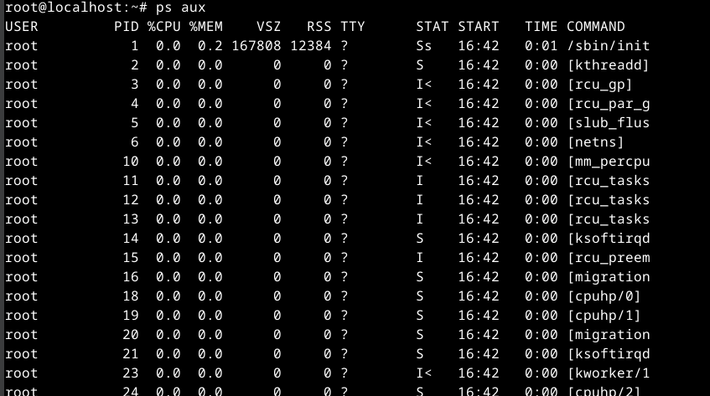

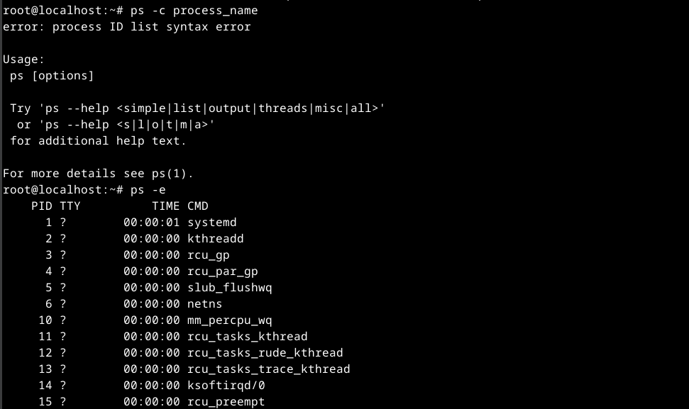

**Check if you have any background processes running, and if so, which ones?**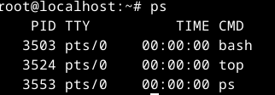

**Resume the execution of a suspended background process, first bringing it to the foreground, then suspending it again, and finally resuming its execution in the background.**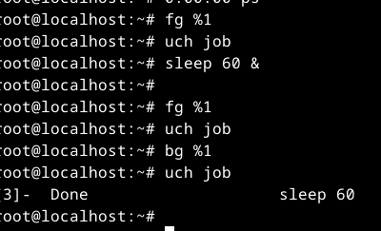

1. **Purpose of the /proc directory in Linux systems. What information does it store?**

- **Purpose:** The `/proc` directory serves as a virtual filesystem providing access to information about current processes and system parameters. It allows accessing various system resources and configurations in the form of files and directories.

- **Information:** In the `/proc` directory, you can find files and subdirectories represented by numbers corresponding to Process . These files contain diverse information about each process, such as memory usage, state, command line, and more.

2. **Dynamically identify which of three processes currently uses the most memory. What percentage of memory does it consume from the total?**

- To dynamically identify the process using the most memory among three, you can use commands like `top` or `htop`.

3. **How to obtain the hierarchy of parent processes in Linux systems? Provide its structure and characterization.**

- To obtain the hierarchy of parent processes, you can use the `pstree` command. It displays the structure of processes in a tree format, where each process has a parent and may have child processes.

4. **Difference between the top and ps commands?**

- `ps` displays information about selected processes in a static manner, while `top` shows an interactive table of active processes and system resources dynamically.

5. **What additional features does htop provide compared to top?**

- `htop` offers a colored and interactive interface, supports scrolling and real-time sorting, and allows process management using keyboard shortcuts, making it more convenient and powerful than the standard `top`.

6. **Describe the components of your mobile OS for monitoring running processes?**

- As an AI, I don't have a specific mobile OS. However, mobile OS typically includes tools or apps like "Task Manager" or "System Monitor" for monitoring and managing running processes.

7. **Does your mobile OS support terminal control of process operations? Describe how.**

- Usually, mobile OS, such as iOS and Android, does not provide direct user access to the terminal or terminal commands through the user interface.

8. **Is it possible to install third-party tools that allow organizing management and monitoring of processes on your mobile phone? Briefly describe them.**

- Some third-party apps for monitoring and managing processes may be available through mobile OS app stores. Apps like "Task Manager" or "System Monitor" allow users to view and control running processes and resource usage.